Kid’s Club
2017
Gabriola Fellowship Church

Kid’s Club
2017
Gabriola Fellowship Church



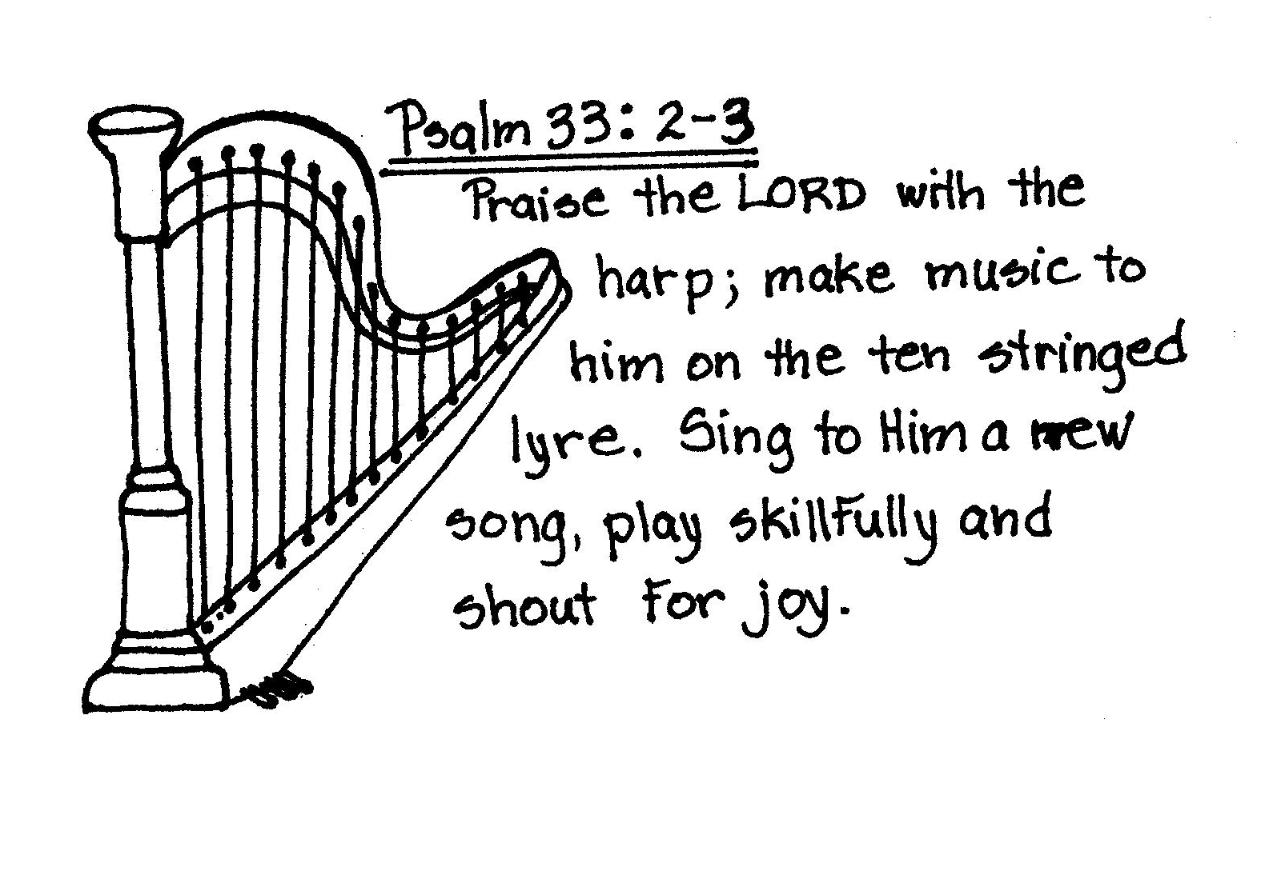

For Kid’s Club Music Downloads
Visit
www.gabriolafellowship.com
For Kid’s Club Music Downloads
Visit
www.gabriolafellowship.com

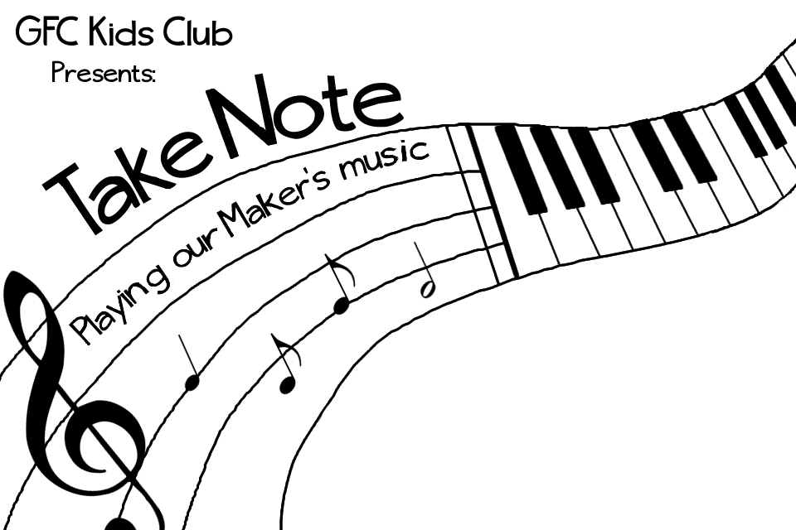

Creator take me in your hands
And let your Spirit blow through me
To make your song heard in this land
A song of peace and victory

I will be
Cleaned up, tuned up,
Lifted up and loud enough
For all who need to hear

Those notes that
Rise above, speak your love
Hands will join and feet will move
And know their God is near

So Father take me in your hands
And let your Spirit blow through me
With all the others in your band
Making some holy harmony
Creator take me in your hands
(Let me be an instrument)
And let your Spirit blow through me
(Let me be an instrument)
In Your Hands
In Your Hands
Creator take me in your hands
And let your Spirit blow through me
To make your song heard in this land
A song of peace and victory

I will be
Cleaned up, tuned up,
Lifted up and loud enough
For all who need to hear

Those notes that
Rise above, speak your love
Hands will join and feet will move
And know their God is near

So Father take me in your hands
And let your Spirit blow through me
With all the others in your band
Making some holy harmony
Creator take me in your hands
(Let me be an instrument)
And let your Spirit blow through me
(Let me be an instrument)
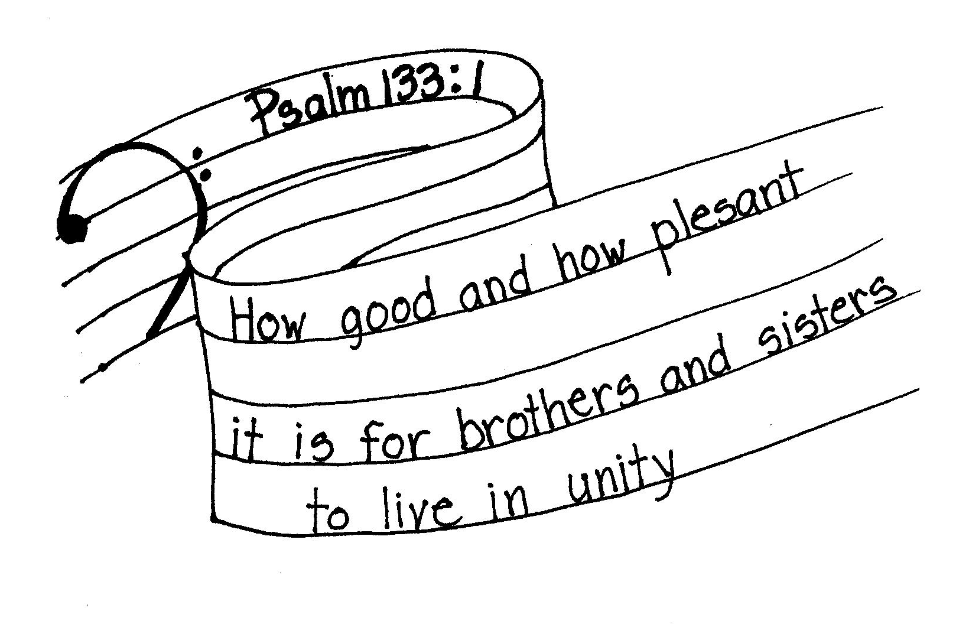

Give Me Grace
Give me grace for a heart of love
Give me grace for a mind of peace
Give me grace to take what comes with joy
So give to me your grace, and fill me with your power

Give me grace for a heart to serve
Give me grace not to lose my nerve
But to stand in the way of love
So give to me your grace, and fill me with your power
Give me grace when the day is long
Give me grace when the foe is strong
Give me grace in my darkest hour
So give to me your grace, and fill me with your power

Give me grace to sing your song
Give me grace to see it through
Give me grace to the very end
Grace to be your child, and grace to be your friend

Give Me Grace
Give me grace for a heart of love
Give me grace for a mind of peace
Give me grace to take what comes with joy
So give to me your grace, and fill me with your power

Give me grace for a heart to serve
Give me grace not to lose my nerve
But to stand in the way of love
So give to me your grace, and fill me with your power
Give me grace when the day is long
Give me grace when the foe is strong
Give me grace in my darkest hour
So give to me your grace, and fill me with your power

Give me grace to sing your song
Give me grace to see it through
Give me grace to the very end
Grace to be your child, and grace to be your friend

Music Inside
Nobody with a heart-beat can deny
We've got some kinda music deep inside
And every time your foot steps on the ground
The rhythm wants to find a joyful sound
And since it's true that we were made this way
An instrument of love for God to play
Then if you wanna know what life's about
You'll let the Maker's music come on out
Gonna clap my hands
Gonna stomp my feet
Gonna show God's love to the folks I meet
Gonna drum gonna strum gonna blow my horn
Gonna play my part, that's why I was born
How could He make a song with one like me?
When brokenness has left me out of key?
But Jesus said to me, “do not despair,
I paid the total cost of your repair”
Gonna clap my hands…
Music Inside
Nobody with a heart-beat can deny
We've got some kinda music deep inside
And every time your foot steps on the ground
The rhythm wants to find a joyful sound
And since it's true that we were made this way
An instrument of love for God to play
Then if you wanna know what life's about
You'll let the Maker's music come on out
Gonna clap my hands
Gonna stomp my feet
Gonna show God's love to the folks I meet
Gonna drum gonna strum gonna blow my horn
Gonna play my part, that's why I was born
How could He make a song with one like me?
When brokenness has left me out of key?
But Jesus said to me, “do not despair,
I paid the total cost of your repair”
Gonna clap my hands…

Your life is a song
Begun by God above in love
Your life is a song

This song has a beat
That you can change or you can keep
Your life is a song

Dear Lord let me sing in all I do
Reflecting the excellence of You
Back to You
I’m living Your song
You live out the words
The harmonies are yours to choose
Your life is a song

This Song that becomes
Your own, your tempo, vibe and beat
Your life is a song

Dear Lord let me sing in all I do
Reflecting the excellence of You
Back to You
I’m living Your song

Your song you perform it now
Your audience is God
Your life is a song
Your Life is a Song
You live out the words
The harmonies are yours to choose
Your life is a song

This Song that becomes
Your own, your tempo, vibe and beat
Your life is a song

Dear Lord let me sing in all I do
Reflecting the excellence of You
Back to You
I’m living Your song

Your song you perform it now
Your audience is God
Your life is a song
Your life is a song
Begun by God above in love
Your life is a song

This song has a beat
That you can change or you can keep
Your life is a song

Dear Lord let me sing in all I do
Reflecting the excellence of You
Back to You
I’m living Your song
Your Life is a Song

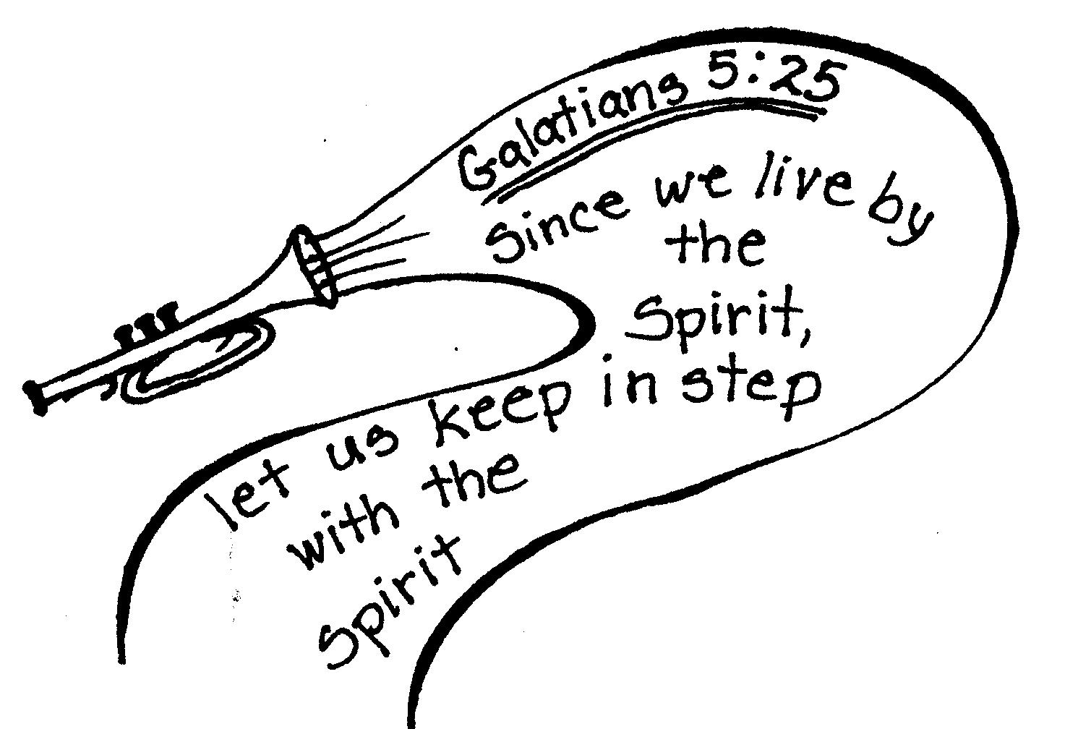

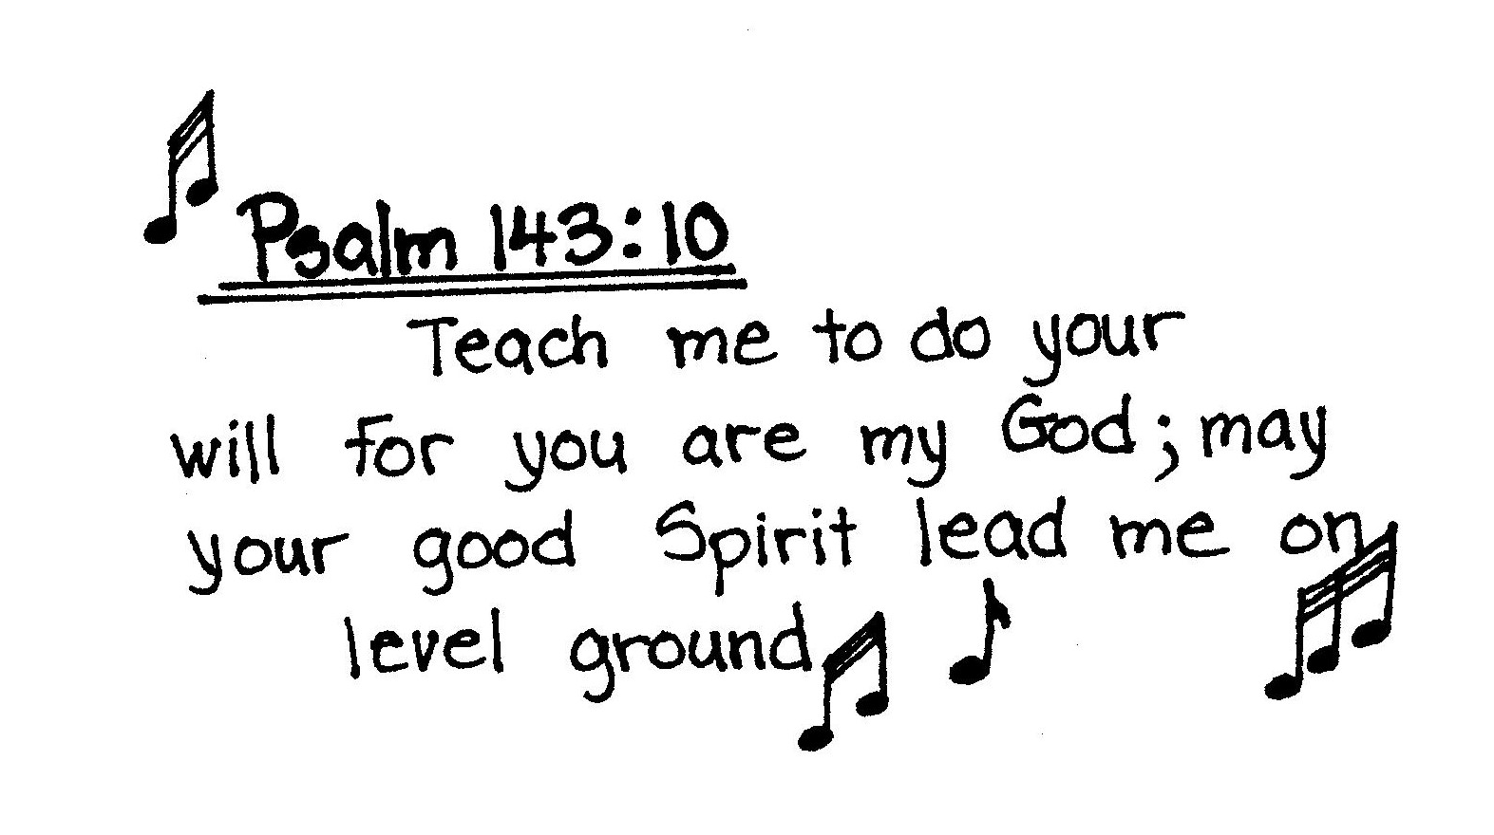

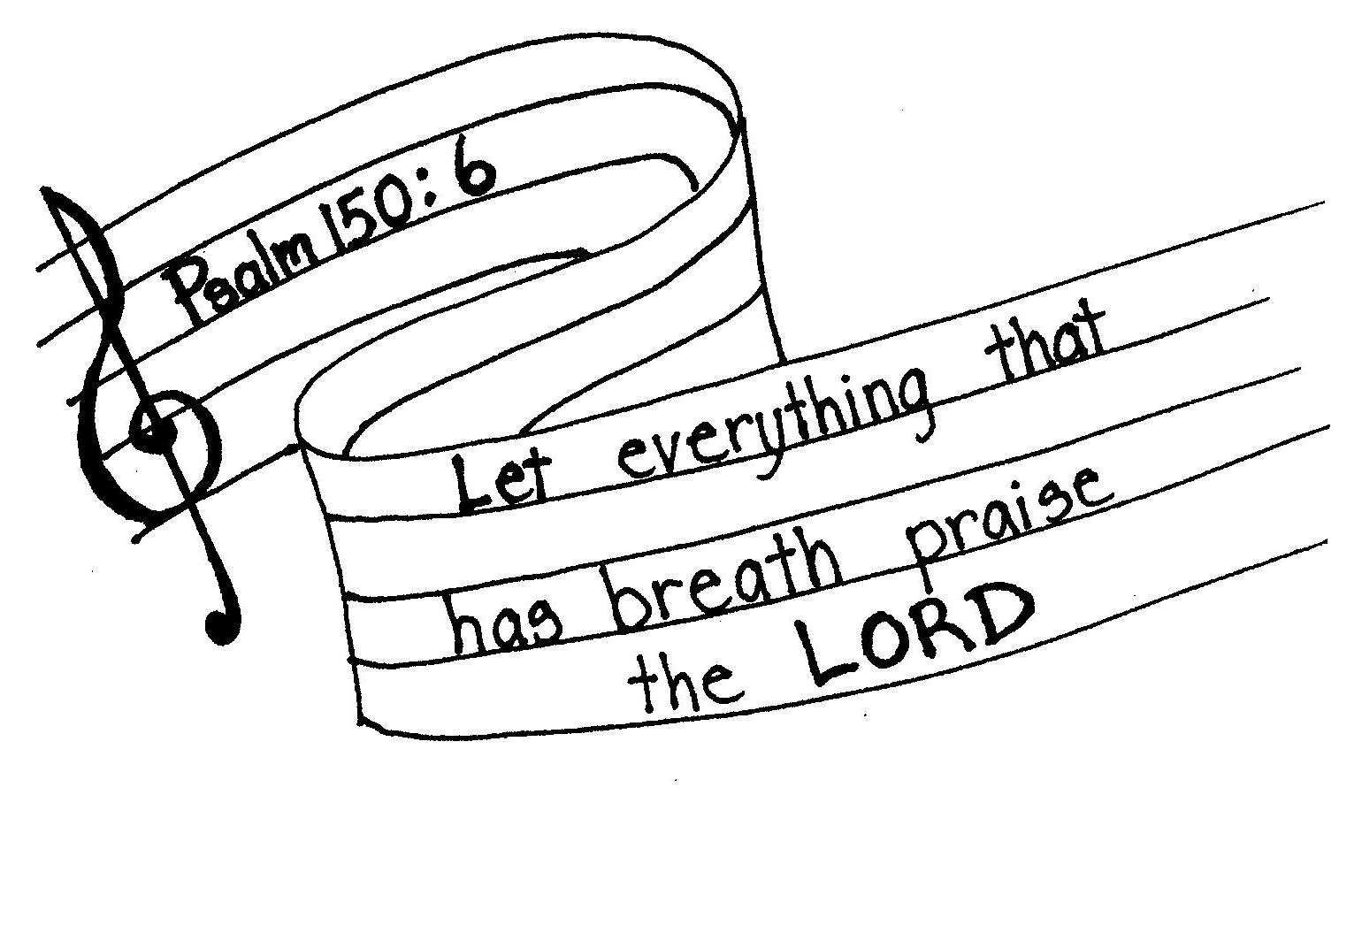

Why Sing
There’s not a better why
To sing a song
There’s not a greater who to sing it to
Not a finer way to start a day
Than calling out to you, Jesus
Giving thanks to you

There's never been a where
That you aren't near
Not a single prayer that you can't hear,
When we know the joy that your love brings
Then you become the Why, Jesus
That we want to sing.
And any kind of what
That happens now
You're gonna make it good for me some how
And I will see your glory, you know when
so I will sing your praises, Jesus
Joyful until then
Why Sing
There’s not a better why
To sing a song
There’s not a greater who to sing it to
Not a finer way to start a day
Than calling out to you, Jesus
Giving thanks to you

There's never been a where
That you aren't near
Not a single prayer that you can't hear,
When we know the joy that your love brings
Then you become the Why, Jesus
That we want to sing.
And any kind of what
That happens now
You're gonna make it good for me some how
And I will see your glory, you know when
so I will sing your praises, Jesus
Joyful until then

